Investigating the role of climate, geomorphology, and hydrology in creating environmental hazards in Saluk National Park and Protected Area.
Gholam Reza Maghami Moghim

- Department of Geomorphologi, Faculty of Earth Sciences, Damghan University, Damghan, Iran.
E-mail: gh.maghami@du.ac.ir

Article Info | ABSTRACT
Article type:  Research Article  Article history:  Received  Received  Accepted  Published online  Keywords:  natural hazards  national parks  protected areas  Saluk  Esfrain | Objective: “The main and overall objective of this research was to identify natural hazards threatening Saluk National Park and Protected Area. In this regard, based on the assumptions of this research, in addition to the main objective, three sub-objectives were also determined for it. The sub-objectives include identifying hazards arising from climatic, geomorphological, and hydrological conditions.  Method: This research was conducted using field and library methods and descriptive analytical methods. The aim of the field studies was to identify the plant and animal species of this park and protected area, which was done using interviews with environmentalists, people living in villages adjacent to the park, and the results of censuses conducted by the Environment Organization. In library studies, concepts and definitions related to the environment and natural hazards were extracted from books available in libraries and documents of the Environment Organization. Statistics from meteorological stations in the region were used to study the climate of the region.  Results: Initial studies suggested that climatic, geomorphological, and hydrological hazards may be the most important natural hazards of the park. Based on the studies, climatic hazards including drought, frost, and frost have greater impacts in the study area. Geomorphological hazards of the park resulting from external dynamic processes including landslides, landslides, and erosion are ranked second, and hydrological hazards, especially river floods in the eastern part of the park in the Ruin River valley and the southern alluvial fans of the park, are ranked third.  Conclusions:  The most important conclusion of this research is that the natural hazards of this park naturally act as an ecological moderator. And these hazards can have detrimental effects on this park when they interact with negative human interventions, but if they are aligned with positive human actions, their effects will not have a significant destructive impact on this park.
Cite this article: Last Name, Initial., Last Name, Initial., & Last Name, Initial. (2024). Title of paper in lower case letters (except for initial letter of first word, initial of first word after a colon, and proper nouns). Spatial Analysis Environmental Hazards, 47 (1), 1-20. http//doi.org/000000000000000000


© The Author(s) Publisher: Kharazmi University
DOI: http//doi.org/0000000000000000000000

EXTENDED ABSTRACT
Introduction
National parks and protected areas have been established with the aim of protecting biodiversity, threatened plant and animal species, and maintaining ecological balance. Due to the importance of these areas in various aspects of human life, many studies have been conducted on them. Nagoji (2000) in Mombasa National Park in Kenya, Buckley and Brau (2017) in Australia, Brewer (2005) in Faro National Park in Cameroon, Orozco et al. (2016) in Argentina conducted studies in this field.
Although Iranians can be considered the founders of national parks and protected areas (Maghami Moqim, 1379: 10) and place this country among the top countries in the world in terms of the existence of national parks and protected areas, the studies conducted in this field are not significant. Among the few studies conducted in this regard, we can mention the studies of Nikandish in Karkheh National Park and Protected Area in 2018 and Maghami Moqim in Saluk National Park and Protected Area in 2010.
Saluk Protected Area was designated as a protected area by Resolution No. 48 dated 1352/9/20 and was upgraded to a national park in 2001. Although this area has great potential in the environmental field, numerous natural hazards cause great damage to it every year. The continuation of these damages will disrupt various aspects of the vegetation and animal life in this park and its vicinity.
This research aims to study the natural threats to the Saluk Park and Protected Area, so that its results can be used to manage natural disasters, reduce the destruction of vegetation and animal life, manage floods, strengthen ecosystems, reduce environmental pollution, and manage water resources.
Methods
- Geographical location of the study area
Saluk National Park and Protected Area is located in the northwest of Esfarayen County and northeast of Iran with an area of ​​19,900 hectares. In terms of geographical coordinates, it is located between the 37⁰ 08′ to 37⁰ 15′ North latitude and the 57⁰ 06′ to 57⁰ 16′ East longitude. The closest way to access the area is the Sankhast-Esfarayen asphalt road. This area is located 20 kilometers from Esfarayen City and 30 kilometers from Bojnord City, the capital of North Khorasan Province.
- Data and methodology
In terms of methodology, this research was conducted using field and library methods and a descriptive analytical approach. Field studies were conducted every two weeks for 4 years from 2018 to 2022 and in all seasons. The aim of the field studies was to identify plant and animal species. In library studies, concepts and definitions related to the environment and natural hazards were extracted from books in libraries and documents of the Environment Organization. To study the climate of the region, statistics from the Esfarayen and Bojnourd synoptic stations were used. The climate type of the region was classified based on Demarton's classification.
To determine the topography of the area, a hypsometric profile and contour map of the area were drawn. The area maps were based on the 1:50,000 topographic map of the Armed Forces Geographical Organization and the 1:100,000 geological map of the area, using Adobe Illustrator and Arc GIS software.
Results
Threatening natural hazards, National Park and Protected Area salok.
- Climate hazards
If the values ​​of climatic elements of a place increase or decrease compared to its average, climatic hazards arise (Khalidi, 1998:119). The climate hazards of Saluk National Park and Protected Area can be examined in two ways: hazards resulting from rainfall irregularities and hazards resulting from temperature fluctuations. Precipitation irregularities are one of the most dangerous natural threats to plant and animal life. Irregularities in precipitation cause drought. Since the establishment of this park and protected area (1973), 26 droughts have occurred in it. The most severe drought occurred in 2008, the most widespread in 2001, the most dangerous in 2013-2014, the most prolonged in 2017-2018, and the most severe in 2010, 2011, 2012, 2013, and 2014 (Hashemi Devin and Ahangarzadeh, 2013). The impacts of drought on this park were assessed in two parts: direct and indirect. In the direct impacts, many plants are either destroyed or damaged. In the indirect impacts, many plants are destroyed by drought-related fires. Also, in drought years, the lack of fodder causes livestock farmers to encroach on the park's pastures and destroy its vegetation.
Like plants, the direct and indirect effects of drought on the animal life of this park are significant. Regarding the direct effect of drought on the losses of animal life in the region, it can be said that in years when rainfall is less than the average for the region, animal losses have increased. The indirect effects of drought on animal life can be examined in the form of vulnerability to fires, escape of animals from the area, and collisions with vehicles and unauthorized logging. Also, in drought years, the animals of this park move to the eastern side of it, i.e. the Ruin River Valley, to access water. In this movement, they are either caught by hunters or collide with vehicles traveling on the road adjacent to this park.
Due to its diverse topography and location on the path of Siberian high pressure, Saluk National Park experiences wide temperature fluctuations. These fluctuations pose many risks to its vegetation and animal life, one of which is frostbite. This phenomenon occurs due to the early arrival and late departure of the Siberian high pressure in the region. With the arrival of this high pressure, the temperature of this park drops sharply. The early arrival of this high pressure causes autumn frost and its late departure causes spring frost (Maghami Moqeem, 1379: 40). Frostbite also indirectly causes damage to animals by affecting the vegetation. This process in the region begins in late November, reaches its maximum in the middle of the month, decreases in March, and ends in April.
- Geomorphological hazards
Among geomorphological hazards, topographic hazards are more important. These hazards are significant due to their impact on weather, animal falls from heights, slope movements, and the creation of physiological stresses. Heavy snowfall in the mountainous northern part of the park causes heat stress for the animals of the park, causing them to migrate to the tropical areas of the south of the park. This can accelerate the process of desertification in the park. This stress can also cause the animals of the park to take refuge in nearby villages, increasing their risk of hunting. In addition, the location of Saluk Peak, the second highest peak in North Khorasan Province, inside this park has caused climbers to climb this peak every year, which can cause fires in this park. Most of the fires in this park have occurred on Thursdays and Fridays, which is largely related to the presence of tourists inside this park. Also, the sense of security of wild animals towards climbers can reduce their fear of humans and put them in the clutches of hunters.
Slope movements are another part of the geomorphological hazards of this park that occur in its valleys. Among these hazards, landslides and rockfalls can be mentioned. Landslides are observed in steep valleys of this park, such as the Siah Khaneh Valley at the site of the old Esfarayen-Bojnourd road, the route of the gas pipeline in the Sarmaran Valley. Landslides are another hazard that occurs in the mountainous areas of this park. This phenomenon occurs in a large part of the valleys and fault precipices of this park and kills its animals. This phenomenon occurs in the form of clod, rock, and biological debris. Rock debris occurs most frequently at the ends of the valleys of the region that have more rocks. Clod (soil) debris forms in the bed of dry valleys. Biological erosion is another geomorphological hazard affecting the southern plain of the park.
- Hydrological hazards
Hydrological hazards are related to river floods that occur in the spring in the form of destructive floods in the valleys and alluvial fans of this park. Since the study area was included in the list of protected areas of Iran (1973), more than 30 destructive floods have occurred in it. These floods flowed in the sub-valleys of the cultural basin called Siah Khane, Chahar Borj, Tuy and Zari, causing damage to the vegetation and animal life of this park. In addition, the permanent Ruin River, which flows on the eastern side of the park and plays an important role in providing water to the park's wildlife due to its abundant water, has a high flood potential. The last flood damage in this river was the loss of 530 livestock of livestock farmers adjacent to the park in the flood of Shahrivar 1402, which were lying in its bed. In addition to animal life, the vegetation of this park is also vulnerable to floods. Floods also activate secondary phenomena, including slope movements in this park. The above-mentioned issues have caused this river to pose the greatest risk to this park in terms of hydrological hazards.
Conclusion

A study of the natural hazards of Saluk National Park and Protected Area showed that among the assumed hazards, weather hazards pose the greatest risk to this park. Among the climatic hazards, drought has the largest share. Drought affects this park and the protected area directly and indirectly. During drought periods, many plants in the region are directly destroyed. Indirect effects of drought on the vegetation of the region occur in two forms: fires and unbalanced grazing in the pastures of this park. The direct effects of drought on animal life manifest themselves in the form of animals escaping from the area and killing them. The indirect effects of this hazard on the animal life of this park are also significant and are often applied to them through fires, hunting by hunters, and collisions with vehicles. After drought, the hazards caused by temperature fluctuations are the most important climatic threat to this region. Due to the location of this park on the path of the Siberian high pressure, the phenomenon of frostbite is of great importance. The early arrival of this high pressure causes autumn frostbite and its late departure causes spring frostbite. Frostbite indirectly causes animal losses by affecting vegetation. The impact of this hazard in the region is periodic and starts in November, reaches its maximum in January, decreases in March, and ends in April.
After climatic hazards, geomorphological hazards are in second place. These hazards often manifest themselves in the form of slope movements in this park. The probability of these movements occurring in the Siyahkhaneh Valley, landslides in the middle channels of the Sarmaran and Chaharborj alluvial fans, rock falls in the Pish Qala valleys, cliffs and gorges created by its faults, and biological landslides in the northern heights of this park are higher. Also, due to the decrease in predators, the number of herbivores has increased, and due to overgrazing, conditions have been created for biological erosion in the southern plain of the park. In terms of hydrological hazards, destructive floods in the valleys of this park and its surroundings have killed dozens of animal species and destroyed dams and plant species. The most important conclusion of this study is that despite the presence of various natural hazards, the park is still intact and many endangered animals continue to live within the park, which indicates that the natural hazards of the park act as an ecological moderator. These hazards can have detrimental effects when they interact with negative human interventions, but if they are in line with positive human actions, their effects are not significant.

بررسی‌نقش آب‌وهوا،ژئومورفولوژی و هیدرولوژی در ایجاد مخاطرات محیطی در پارک ملی و منطقه حفاظت شده سالوک.
غلامرضامقامی مقیم1
1-دانشیار گروه ژئومورفولوژی، دانشکده علوم زمین، دانشگاه دامغان، دامغان، ایران.
gh.maghami@du.ac.ir

اطلاعات مقاله | چکیده
نوع مقاله:  مقاله پژوهشی  تاریخ دریافت:  تاریخ بازنگری:  تاریخ پذیرش:  تاریخ انتشار:  کلیدواژه‌ها: مخاطرات طبیعی، پارک های ملی، مناطق حفاظت شده، سالوک، اسفراین | اهداف: هدف اصلی و کلی این تحقیق شناسایی مخاطرات طبیعی تهدید کننده پارک ملی و منطقه حفاظت شده سالوک بود. در این راستا براساس فرضیات این تحقیق علاوه بر هدفی اصلی سه هدف جزئی نیز برای آن تعیین گردید. در اهداف جزئی شناسایی خطرات ناشی از شرایط آب‌وهوایی، ژئومورفولوژیکی و هیدرولوژیکی مدنظر می باشد.  ‌روش پژوهش: این تحقیق با روش میدانی و کتابخانه ای و به شیوه تحلیلی توصیفی انجام شد. هدف مطالعات میدانی شناسایی گونه‌های گیاهی و جانوری این پارک و منطقه حفاظت شده بود که با استفاده از مصاحبه با محیط بانان، مردم ساکن در روستاهای مجاور پارک، نتایج سرشماری های انجام شده توسط سازمان محیط زیست انجام شد. در مطالعات کتابخانه ای مفاهیم و تعاریف مرتبط با محیط زیست و مخاطرات طبیعی از کتاب های موجود در کتابخانه‌ها، اسناد سازمان محیط زیست استخراج گردید. جهت مطالعه آب وهوای منطقه از آمار ایستگاه های هواشناسی منطقه استفاده شد.  یافته‌ها: مطالعات اولیه این فرض را تداعینمود که ممکن است مخاطرات آب‌وهوایی، ژئومورفولوژیکی و هیدرولوژیکی مهمترین مخاطرات طبیعی این پارک باشند. براساس مطالعات انجام شده، مخاطرات آب‌وهوایی شامل خشکسالی، سرمازدگی و یخبندان تاثیرات بیشتری در منطقه مورد مطالعه دارند. مخاطرات ژئومورفولوژیکی این پارک ناشی از فرایندهای دینامیک بیرونی ازجمله حرکاتدامنهای لغزش و ریزش و فرسایش است در مرتبه دوم قرار می گیرد و مخاطرات هیدرولوژیکی به خصوص سیلاب های رودخانه ای در شرق این پارک در دره رودخانه روئین و مخروط افکنه های جنوبی این پارک در رده سوم قرار می‌گیرند.  نتیجه‌گیری: مهمترین نتیجه حاصل از این پژوهش این است که مخاطرات طبیعی این پارک به صورت طبیعی به عنوان یک عامل تعدیل کننده اکولوژیکی عمل می‌نمایند. و این مخاطرات زمانی می‌تواند بر این پارک اثرات زیانبار داشته باشند که با دخالت‌های منفی انسانی در تعامل باشند اما اگر با اقدامات مثبت انسانی همسو باشند اثرات آنها تأثیر مخرب قابل توجهی در این پارک نخواهند داشت.
استناد: نام خانوادگی، نام؛ نام خانوادگی، نام؛ و نام خانوادگی، نام (1403). عنوان مقاله. تحلیل فضایی مخاطرات محیطی، 47 (1)، 1-20.
http//doi.org/0000000000000000000000000
ناشر: دانشگاه خوارزمی © نویسندگان
مقدمه
پارک هاي ملی و مناطق حفاظت شده با هدف حراست از تنوع زیستی، گونه‌های گیاهی و جانوری مورد تهدید، و حفظ تعادل اکولوژیکی‌شکل‌گرفته‌اند.‌
امروزه مدیریت این مناطق یکی ازچالش برانگیزترین مسایل زیست محیطی محسوب می‌شود(مصفایی، جهانی، زارع و همکاران،2020). به دلیل اهمیت این مناطق درشئونات مختلف زندگي انسان مطالعات زیادی درمورد آنها انجام شده است. ناگوجی(2000)درمطالعه‌ای در پارک ملی موم باسا دركشوركنيا به اين نتيجه رسيد كه ارتباط نزدیکی بين شرایط اقتصادی ماهيگيران مجاور اين پارك ومحیط زیست آن وجوددارد. باکلی و براو(2017) درمطالعه‌اي دركشور استراليا اهميت اين پارك‌ها را از جهت تأثيرگذاري در سلامت انسان مورد بررسي قرار داده، به اين نتيجه رسيدند كه اين مناطق تأثيرات زيادي در سلامت انسان دارند، به همین دلیل محافظت از آنها ضروری است. برویر (2005) در پارك ملي فارو در كامرون اينسلبرگ‌هاي اين پارك را مطالعه نمود و به دلیل دور بودن‌آن از فعالیت‌های انسانی این مناطق را برای فعالیت‌های پژوهشی مناسب دانست. پرسی و همکاران در یک مطالعه در سال 2015 به این نتیجه رسیدند که عملکرد دولت ها در مورد مناطق حفاظت شده با اهدف اساسی این مناطق هماهنگ نیست و این ناهماهنگی سبب میشود تا مخاطرات‌زیادی این مناطق را تهدیدنماید(پرسی، ویسکونتی، و فرارو ،2015). در مطالعه‌ای دیگردر کشور آرژانتین مشخص شد درمقایسه با مناطق مجاور، آسیب کمتری متوجه پوشش گیاهی و گونه‌های جانوری پارک‌های ملی ومناطق حفاظت شده است، بنابراین این مناطق ابزاري مفید برای محافظت‌ از پوشش گیاهی وزندگی جانوری به حساب می‌آیند (اوروزکو،انریکویز،کاردینار وهمکاران،2016).
هرچند می‌توان ایرانیان را بنیانگذران پارک‌های ملی و مناطق حفاظت شده به حساب آورد( مقامی مقیم، 1379: 10) و از نظر وجود پارک‌های ملی و مناطق حفاظت شده این کشور را در ردیف کشورهای برترجهان قرارداد. اما مطالعات انجام شده در این زمینه قابل توجه نیست. از معدود مطالعات انجام شده در این خصوص، می‌توان به مطالعات نیک اندیش در پارک ملی و منطقه حفاظت شده کرخه اشاره نمود. او در این مطالعه به این نتیجه رسید که مخاطره کمبود محیط‌بان بیشترین وخطرآلودگی خاک ‌کمترین خطر را برای این پارک دارند(نیک اندیش، دشتی و سبزقبائی ،1397). او همچنین در مطالعه‌ای دیگر در پارک ملی دز که با استفاده از تکنیک دلفی انجام داد به این نتیجه رسید که مخاطره شکار غیر مجاز با ضریب نزدیکی 876811/0 بالاترین و آتشسوزی با ضریب 180761/0 پایین‌ترین خطر را برای این پارک داشته‌اند. منطقه حفاظت شده سالوك به استناد مصوبه شماره ۴۸ مورخ ۱۳۵۲/۹/۲۰ شورای عالی حفاظت محیط‌زیست به‌عنوان منطقه حفاظت شده اعلام و در سال 1380 به پارک ملی ارتقاع یافت. هرچند اين منطقه پتانسیل زیادی درزمینه زیست محیطی دارد اما مخاطرات متعدد طبیعی همه ساله خسارات زیادی بر آن وارد می‌نمایند. این مخاطرات تا به حال از سوی محققان مطالعه نشده است. عدم مطالعه دقیق و همه جانبه این مخاطرات سبب استمرار آنها شده، ابعاد مختلف پوشش‌گیاهی و زندگی جانوری‌آن را به خطر خواهد انداخت. در این تحقیق سعی بر این است تا برای اولین بار به صورت تخصصی عوامل تهدید کننده طبیعی این پارک و منطقه حفاظت شده با استفاده ازمطالعات میدانی و کتابخانه ای مورد بررسی قرارگیرد تا از نتایج آن، اطلاعات ارزشمندی برای برنامه‌ریزی حفاظت، کمک به مقامات در به حداقل رساندن اثرات مخاطرات طبیعی و حفاظت از اکوسیستم منحصربه‌فرد آن حاصل گردد. به نظر می رسد در بین مخاطرات طبیعی تهدید کننده این پارک سهم مخاطرات آب‌و هوایی، ژئومورفولوژیکی وهیدرولوژیکی بیشتر از سایر پدیده‎های طبیعی باشد.
روش شناسی پژوهش
1. قلمرو جغرافیایی مورد مطالعه
پارک ملي و منطقه حفاظت شده سالوک با مساحت 19900 هکتار، شامل 8231 هکتار پارک ملی 11677 هکتار منطقه حفاظت شده در شمال باختری‌شهرستان اسفراین و شمال خاوری ايران واقع شده است. این منطقه از شمال به شهرستان بجنورد از جنوب و خاور به شهرستان اسفراین واز غرب به شهرستان سنخواست محدود می‌گردد. از نظر مختصات جغرافیایی بین مدارهای ′08 37⁰ تا ′15 37⁰ شمالی و نصف النهارات ′06 57⁰ تا ′16 57⁰ طول شرقی قراردارد. نزدیکترین راه دسترسی به منطقه جاده آسفالته سنخواست – اسفراین می‌باشد(شكل1). اين منطقه در فاصله 20 کیلومتری شهراسفراین و 30 کیلومتری شهر بجنورد مرکز استان خراسان شمالی قرار گرفته است.
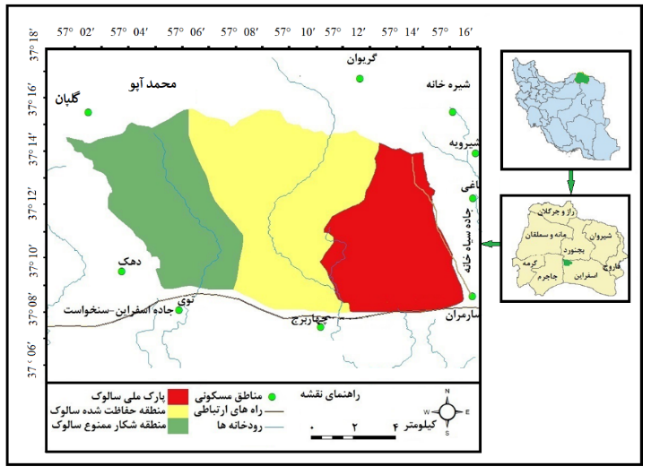
شکل 1- نقشه موقعیت جغرافیایی پارک ملی و منطقه حفاظت شده سالوک در ایران و استان خراسان شمالی
به دليل وسعت زياد، 14 روستا در محدوده جغرافيايي شهرستان اسفراين و بجنورد در پيرامون اين پارك و منطقه حفاظت شده قرار دارند كه طبق آخرين سرشماري نفوس و مسکن 10922 نفر در آنها ساكن هستند.
- داده‌ها و روش کار
از نظر روش شناسی، این تحقیق با روش‌هاي میدانی و کتابخانه‌ای و به شیوه تحلیلی توصیفی انجام شد. مطالعات میدانی هر دو هفته یک بار به مدت 4 سال از سال 1397تا1401و درتمام فصول انجام شد. هدف مطالعات ميداني شناسایی گونه‌های گیاهی وجانوری بود كه با استفاده از مصاحبه با محيط بانان، مردم ساكن در روستاهاي مجاور پارك، نتایج حاصل از سرشماری‌های انجام شده توسط سازمان محیط زیست وعكسبرداري از گونه‌هاي جانوري و گياهي انجام شد. در مطالعات کتابخانه‌ای مفاهیم و تعاریف مرتبط با محیط زیست و مخاطرات طبیعی از كتاب‌هاي موجود در كتابخانه‌ها و اسناد موجود سازمان محیط زیست ومنابع طبیعی استخراج گرديد. درمطالعات زيست محيطي اطلاع از نوع آب و هوا، توپوگرافي وهیدرولوژی منطقه مورد مطالعه ضروری است. به دليل كوهستاني- دشتي بودن، اين پارك آب وهواي متنوعی دارد به همين دليل جهت مطالعه آب‌وهواي دشت جنوبي از آمارایستگاه سينوپتيك اسفراین و آب‌وهواي كوهستاني شمال این پارک از ايستگاه هاي سينوپتيك بجنورد وتبخيرسنج اسدلی استفاده شد.
نوع آب‌وهوای منطقه بر اساس طبقه بندی دمارتن و معادله $IA=\frac{P}{T+10 }$ طبقه بندی گردید براساس این معادله:
P=عبارت است از ميانگين بارندگي منطقه بر حسب ميليمتر
T= عبارت است از ميانگين درجه حرارت بر حسب سانتيگراد
IA= عبارت است از مقدار شاخص
طبق اين فرمول مقادیركمتر از 10 خشك، بين 10 تا 50/19 نيمه خشك، بين 20 تا 9/23 مديترانه اي، بین 24 تا 9/27 نيمه مرطوب، بين 28 تا 9/34 مرطوب وبزرگتر از 35 بسيارمرطوب می باشد. جهت مشخص شدن ماه های خشک منحنی آمبروترمیک منطقه بر اساس آمار ۴۶ ساله ایستگاه‌های سینوپتیک بجنورد و تبخیر سنج بالاخوش ترسیم شد. (شکل 2).
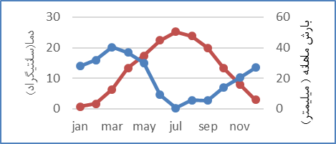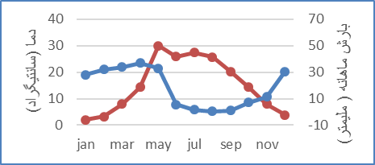
شکل2- منحنی آمبروترمیک منطقه مورد مطالعه ایستگاه خوش(سمت چپ) و ایستگاه بجنورد(سمت راست)(منبع داده‌های هواشناسی ایستگاه سينوپتيك بجنورد وتبخیرسنج بالاخوش1400-1354)
برای مشخص شدن توپوگرافي منطقه نمودار هیپسومتریک آن ترسیم شد.ترسیم این نمودار برای مطالعه توپوگرافی یک مکان ضروری است(احمدی،359:1367). جهت ترسيم این نمودار‌ از نقشههاي توپوگرافي1:50000 استفاده شد. براین اساس فاصله منحني ميزان‌هاي اين نقشه از كمترين ارتفاع يعني 1140 آغاز وتا بيشترين ارتفاع يعني 2800 متر به فاصله 100 مترطبقه بندي شد و مساحت بين دو منحني ميزان اندازه گيري وباتوجه به مساحت هرمنحني نمودار هيپسومتريك ترسيم گرديد(شكل3). علاوه بر منحنی هیپسومتریک، جهت تکمیل مطالعات توپوگرافی نقشه خطوط ارتفاعی منطقه نیزترسیم شد(شکل4).
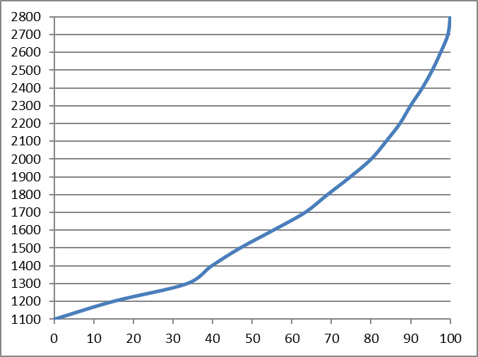
شکل3- منحنی هیپسومتریک منطقه مورد مطالعه
نقشه‌های منطقه برپایه نقشه توپوگرافی 1:50000 سازمان جغرافیایی نیروهای مسلح ونقشه 1:100000 زمین شناسی منطقه و با استفاده از نرم افزار Adobe Illustrator و Arc GISترسیم شد.

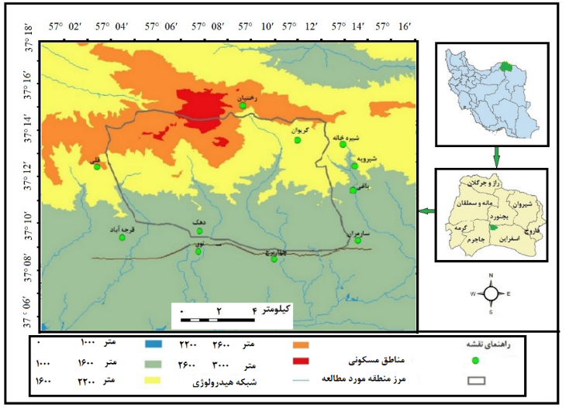
شکل4-نقشه خطوط ارتفاعی پارک ملی ومنطقه حفاظت شده سالوک(منبع:سازمان جغرافیایی نیروهای مسلح نقشه توتوپوگرافي1:50000)
آمار مورد نیاز برای مطالعات کمی این پژوهش ازطريق مطالعات ميداني، اسناد موجود در سازمان محیط زيست، منابع طبيعي و هواشناسي خراسان شمالي تهیه و در جدول شماره۱ درج و در نرم افزارspss مورد تجزیه و تحلیل قرار گرفت. آمار مربوط به خشکسالی های تهدید کننده این پارک از داده‌های 47 ساله (1355-1402) ثبت شده در ایستگاه‌های هواشناسی و باران‌سنج‌های منطقه ومجاور آن استخراج و در ستون دوم این جدول شماره۱ ثبت گردید.آمار مربوط به تلفات سالانه جانوران سخت ترین قسمت جمع‌آوری داده‌ها بود که از منابع رسمی و غیر رسمی مانند اطلاعات موجود در سازمان های محیط زیست، منابع طبیعی، جهادکشاورزی، محیط بانان، جراید و رسانه‌های محلی و منابع غیر رسمی مانند مردم روستاهای مجاور، عشایر منطقه و شکارچیان منطقه استخراج و در ستون چهارم جدول درج شد. آمار مربوط به سیلاب‎های منطقه(ستون سوم) با استفاده از داده‌های ایستگاه‌های هیدرومتری منطقه به خصوص ایستگاه هیدرومتری رودخانه رویین تهیه گردید. آمار مربوط به آتش‌سوزی‌های منطقه‌از داده های موجود در فرمانداری، اداره محیط زیست و منابع طبیعی و نشریات محلی و کشوری تهیه گردید(ستون چهارم جدول۱).
آمار مورد استفاده در این جدول از منابع معتبری تهیه شده و بخش زیادی از زمانبدی این پژوهش را به خود اختصاص داده است در مورد صحت و اعتبار آمار مورد استفاده باید گفت به دلیل اینکه بخش قابل توجهی از داده ‌های مورد استفاده این پژوهش توسط ادارات دولتی تهیه شده و این داده‌ها برای ادارات مرتبط نقش کلیدی و حیاتی دارند از صحت بالایی برخوردار می باشد.
بخش زیادی از داده‎های این پژوهش‎که مربوط به داده‎های زیست محیطی است از سازمان محیط زیست و منابع طبیعی تهیه شده است. این دوسازمان همه ساله در زمان مشخص، پوشش گیاهی و زندگی جانوری این پارک و مجاور آن را با جدیدترین و دقیق‎ترین روش‌های موجود سرشماری می‌نماید بنابراین آمار این دو سازمان می‎تواند با اطمینان بالایی مورد استفاده قرار گیرد. اطلاعات ثبت شده در ایستگاه‌های هیدرومتری منطقه که با ابزاری ماشینی انجام می‌شود واز تاسیس آن نزدیک به نیم قرن می گذرد نیز دلالت بر صحت آمار مورد استفاده در این پژوهش دارد. اما در خصوص صحت آمار آب‌وهوای منطقه باید گفت به دلیل وجود چندین بارانسج و ایستگاه هواشناسی در منطقه مورد مطالعه آمار این ایستگاه با اطمینان زیادی مورد استفاده قرار گرفت زيرا بر اساس استانداردهای سازمان جهانی آب و هوا شناسی در مناطق دشتی فاصله باران سنج ها از یکدیگر تا شعاع 575 کیلومتر مربع است(مقیمی و محمودی،50:1383) که این فاصله برای باران سنج ها و ایستگاه های منطقه کمتر از 300 کیلومتر مربع می‌باشد. از نظر بازه زمانی هم بیشتر ایستگاه های هواشناسی منطقه که از آمار آنها استفاده شد سابقه ای بیشتر از ۴۰ سال دارند.
یافته‌های پژوهش
براساس فرضیات این پژوهش، مخاطرات آب وهوایی، ژئومورفولوژیکی وهیدرولوژیکی مهمترین مخاطرات تهدید کننده این پارک محسوب می‌شوند براین اساس مطالعه آب و هوا، ژئومورفولوژی و هیدرولوژی آن ضروری است.
1. آب‌وهوای منطقه
به دلیل حاکمیت شرایط کوهستانی- دشتی، در منطقه مورد مطالعه آب‌وهوای متنوعی حکم فرما است. بر اساس طبقه بندي دمارتن آب و هواي این پارک در ايستگاه‌هاي اسدلي و بجنورد در كوهستان هاي شمالی نيمه خشك ودر ايستگاه بالا خوش و اسفراين دردشت جنوبي در حدمرزخشك و نيمه خشك قراردارد. متوسط بارش آن 219میلی متر است که از شمال به جنوب کاهش می‌یابد. ماه اسفند با ميانگين 54 ميلي‌متر پرباران ترين و مرداد با 8/2 ميلي‌متر كم باران‌ترین ماه سال‌مي‌باشد. متوسط دماي آن 12 درجه سانتيگراد است. سردترين ماه سال دي ماه و گرم ترين ماه آن تيراست. (سازمان هواشناسي ايران 1400-1354).
2. ژئومورفولوژی منطقه
براساس مطالعات هيپسومتريك)شکل4) و نقشه خطوط‌ ارتفاعی منطقه(شکل5)این پارک ومنطقه حفاظت شده ازنظر توپوگرافی شرایط كوهستاني- دشتي دارد. ميانه ارتفاع آن 1540 متر است. يعني 50 درصد آن بيش از 1540 و 50 درصد ارتفاعی كمتر از آن دارند. 15 درصد مساحت ارتفاعي منطقه كمتر از1200 متر و 40 درصد كمتر از 1400 متر دارد. 10 درصد منطقه ارتفاعي بيشتر از 2100 متر دارد. از نظرتوپوگرافی‌ شمال آن‌كوهستاني وجنوب آن هموار است. مهمتریندشت آن دشت سارمران و بلندترين قلهآن كوه سالوك است که در شمال باختری منطقه واقع شده و 3000 متر ارتفاع دارد.
3. هیدرولوژی منطقه
از نظر هيدرولو‍ژي جنوب منطقه در محدوده حوضه آبريز كوير مركزي ايران وشمال آن درحوضه آبريز اترك از زیرحوضه‌های درياي خزر واقع شده‌است. چند شاخه از حوضه آبریز کالشور به نام‌هاي سارمران، چهاربرج، توي و زاري که نقش مهمی در پوشش گیاهی و زندگی‌جانوری این پارک ایفا می‌نمایند در قسمت میانی این پارک جریان دارند. علاوه براین، رودخانه روئین یکی از رودخانه‌های دائمی‌حوضه آبریز کالشور درمرزخاوری این پارک جریان داشته و نقش مهمی در محیط‌زیست این پارک ایفامی نماید.
4.پوشش گیاهی و زندگی جانوری منطقه
از نظر پوشش گیاهی تیره کاسنی یا composite و گونه غالب آن درمنه، گونه گیاهی غالب این پارک است (شكل 5-A وB). پس‌ازدرمنه،کلاه‌ میرحسن وگون دررده بعدی قرارمی‌گیرند(شكل5-CوD). ازنظرگونه‌های‌درختی، درخت‌ارس(شكل5CوE) و زرشك‌كوهي(شكل5-F)گونه غالب جنگلي اين پارك می باشند(مقامی‌مقیم،152:1379).
ازنظرزندگی جانوری‌نیز این پارک‌شرایط متنوعی دارد.کل ‌و بز(شكل5Aسمت‌چپ)، قوچ‌ و میش ‌اوریال(شكل5B سمت‌چپ)، گرازوحشی(5-C سمت‌چپ)، آهو(6-D)، گرگ (6-E سمت‌چپ) و پلنگ (6-Fسمت‌چپ )،كفتار، گربه وحشی، خارپشت، هامستر، تشی‌ و روباه ‌مهمترين گونه‌هاي جانوري اين پارك را تشکیل می دهند.
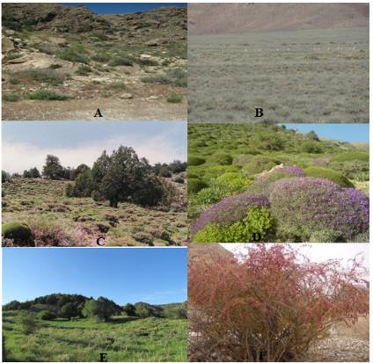
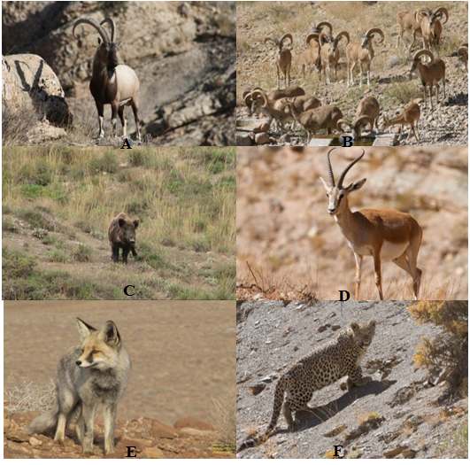

شكل5- گونه هاي غالب جانوري وگیاهی پارك ملي ومنطقه حفاظت شده سالوك(منبع:نگارنده و اداره محیط زیست شهرستان اسفراین)
بحث
1.مخاطرات طبیعی تهدید کننده پارک ملی و منطقه حفاظت شده سالوک
مخاطرات طبیعی تهدیدکننده پارک ملی و منطقه حفاظت شده سالوک براساس فرضیات اولیه تحقیق در سه گروه مخاطرات آب‌وهوایی، مخاطرات ژئومورفولوژیکی وهیدرولوژیکی قابل پهنه بندی(شکل12)و بررسی می‌باشند.
1.1. مخاطرات آب‌وهوایی
اگرمقادیرعناصرآب‌وهوایی یک مکان نسبت به میانگین آن افزایش یا کاهش یابد مخاطرات آب‌وهوایی به وجود می آید(خالدی،119:1377). مهمترین مخاطرات آب‌وهوایی پارک ملی ومنطقه حفاظت شده سالوک بر اساس نقشه پهنه بندی مخاطرات آب‌وهوایی‌آن(شکل۹) عبارتند از:
1.1.1مخاطرات ناشی از بارش
بی نظمی‌های بارش یکی از خطرناک‌ترین تهدیدهای طبیعی برای پوشش گیاهی و زندگی جانوری به حساب می آیند؛ زیرا گیاهان و جانوران یک منطقه اغلب خود را با میانگین بارش و دما وفق داده‌اند. بی نظمی در بارش سبب خشکسالی میگردد. خشکسالی عبارت است از کاهش غیرمنتظره بارش در مدت معین در یک منطقه (علیجانی و کاویانی، 1371: 240). مطالعه آمار ثبت شده در ایستگاه‌های هواشناسی منطقه و مجاورآن نشان می‌دهد از زمان قرارگرفتن این منطقه (سال1352) در ردیف مناطق حفاظت شده ایران، تا کنون 26مورد خشکسالی در آن رخ داده است (جدول1).
جدول1- آمارمربوط به خشکسالی، آتش‌سوزی،سیل،یخبندان بارش و تلفات جانوری در پارک ملی (1355-1402).
سال آبی | خشکسالی | سیل | تلفات جانوری(راس) | آتش سوزی | یخبندان | بارش
56-1355 | 1 | 0 | 35 | 2 | 75 | 181.5
57-1356 | 0 | 1 | 20 | 0 | 10 | 232
58-1357 | 0 | 0 | 10 | 0 | 88 | 261
59-1358 | 0 | 0 | 11 | 1 | 89 | 219
60-1359 | 0 | 2 | 10 | 0 | 102 | 334
61-1360 | 1 | 0 | 30 | 3 | 86 | 186
62-1361 | 1 | 0 | 27 | 2 | 85 | 203.5
63-1362 | 0 | 0 | 18 | 2 | 86 | 220.5
64-1363 | 1 | 0 | 36 | 3 | 87 | 146.5
65-1364 | 1 | 1 | 20 | 2 | 100 | 208
66-1365 | 0 | 3 | 10 | 0 | 86 | 296.5
67-1366 | 0 | 0 | 23 | 0 | 100 | 291
68-1367 | 1 | 0 | 16 | 3 | 92 | 141
69-1368 | 1 | 0 | 11 | 4 | 86 | 127.5
70-1369 | 1 | 0 | 34 | 3 | 87 | 175.5
71-1370 | 0 | 3 | 15 | 0 | 96 | 323.5
72-1371 | 0 | 3 | 15 | 0 | 96 | 284.5
73-1372 | 0 | 0 | 8 | 0 | 87 | 217
74-1373 | 0 | 0 | 7 | 3 | 86 | 265
75-1374 | 0 | 1 | 6 | 1 | 79 | 252
76-1375 | 1 | 0 | 29 | 2 | 100 | 188.5
77-1376 | 0 | 0 | 12 | 0 | 89 | 271
78-1377 | 1 | 1 | 29 | 2 | 99 | 190.5
79-1378 | 1 | 0 | 34 | 3 | 100 | 161
80-1379 | 0 | 0 | 10 | 3 | 86 | 141
81-1380 | 0 | 0 | 9 | 3 | 87 | 278.5
82-1381 | 1 | 1 | 21 | 0 | 100 | 284
83-1382 | 1 | 1 | 34 | 4 | 92 | 177.5
84-1383 | 0 | 0 | 14 | 0 | 95 | 283
85-1384 | 1 | 0 | 28 | 3 | 83 | 194
86-1385 | 0 | 2 | 22 | 0 | 102 | 273
87-1386 | 1 | 1 | 35 | 4 | 87 | 155.5
88-1387 | 1 | 0 | 7 | 3 | 85 | 192.5
89-1388 | 0 | 0 | 6 | 0 | 84 | 276
90-1389 | 1 | 0 | 25 | 1 | 87 | 211.5
91-1390 | 1 | 1 | 27 | 2 | 100 | 205
92-1391 | 1 | 0 | 40 | 3 | 98 | 129.5
93-1392 | 1 | 2 | 39 | 3 | 87 | 134.5
94-1393 | 1 | 1 | 14 | 0 | 100 | 230.5
95-1394 | 1 | 1 | 29 | 1 | 86 | 193
96-1395 | 1 | 1 | 42 | 4 | 85 | 121
97-1396 | 1 | 0 | 50 | 6 | 102 | 109
98-1397 | 0 | 1 | 40 | 0 | 101 | 297
99-1398 | 0 | 2 | 13 | 1 | 88 | 317
00-1399 | 0 | 0 | 21 | 0 | 100 | 290
01-1400 | 1 | 0 | 24 | 4 | 88 | 218.1
02-1401 | 1 | 2 | 35 | 3 | 86 | 209.5
میانگین |  |  |  |  |  | 219
منبع جدول: سازمان های محیط زیست،منابع طبیعی،هواشناسی،مدیریت منابع آب، خبرگذاری فارس، روزنامه خراسان ،نشریه حق و حقوق، پایانامه کارشناسی ارشد نویسنده،اطلاعات محلی و مصاحبه با محیط بانان و بومیان مجاور این پارک (1379-1403)
همچنین مطالعات انجام شده در مورد خشکسـالی‌های‌ استان خراسان شمالی نشان می‌دهد؛ کمتــرین خشکســالی در نــواحی مرکـزي و شـمال باختری و بیشترین آن در نـواحی جنـوب این استان رخ داده‌اند (جعفری ، شاهکویی و قانقرمه 1397). منطقه مورد مطالعه درجنوب این‌استان قرار دارد بنابراین از پتانسیل‌خشکسالی‌بالایی‌ برخوردار است. ‌براساس آمار 47ساله(1355-1402)، شدیدترین خشکسالی این پارک درسال 1387، فراگیرترین آن درسال1380 (ظهیري‌، شریفان، ابارشی وهمکاران،1393)، خطرناکترین آن درسال 1392-1393 (حسین‌پور و فاتحی مرج ،1397) و حادترین آن در سال‌هاي 1369 ،1374 ،1380 و 1388 در این پارک و سرزمین‌های مجاورآن به وقوع پیوسته است (هاشمی دوین و آهنگرزاده،1392). .
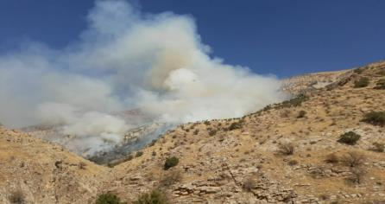
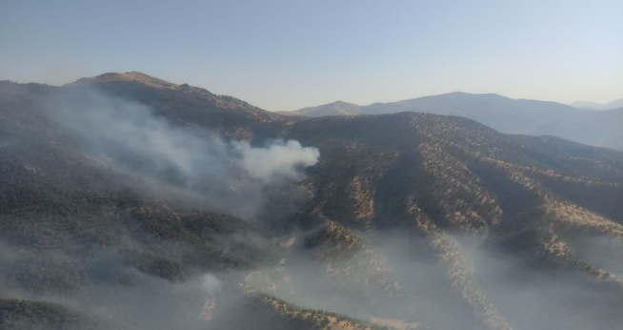
از نظر آسیب پذیری پارک‌ملی و منطقه حفاظت شده سالوک از خشکسالی؛ باید گفت هر چند به دلیل وسعت خشکسالی‌ها تمامی قسمت‌های این پارک و منطقه حفاظت شده تحت تاثیر این پدیده قرارمی‌گیرد؛ اما دشت جنوبی آن آسیب پذیرتراست. تأثیرات خشکسالی در این پارک در دو بخش مستقیم و غیر مستقیم مورد ارزیابی قرارگرفت و مشخص شد درتأثیرات مستقیم، بسیاری از گیاهان این پارک که توان مقاومت دربرابر خشکسالی‌ها را ندارند یا از بین‌ می روند و یا دچار آسیب می‌شوند. به صورت غیر مستقیم هم بسیاری از گیاهان این پارک یا دراثر چرای بیش از حد و یا در اثر آتش‌سوزی‎ آسیب می‌بینند. خشکسالی‌ها احتمال آتش سوزی در مناطق حفاظت شده را افزایش داده باعث نابودی درختان قطور و برخی از گونه‌های جانوری می‌گردد (لسی و همکاران 2024). خشکسالی احتمال آتش سوزی در جنگل‌ها را افزایش می‌دهد، این عامل تاثیر قابل توجهی بر شدت، وسعت و فرکانس آتش دارد. خشکسالی‌ها چندین جنبه، اما نه همه، رژیم‌های آتش‌سوزی را تحت تأثیر قرار می‌دهند(لیتل و همکاران2016).
شکل6- آتش سوزی در پارک ملی و منطقه حفاظت شده سالوک
جهت مشخص شدن بهتر ارتباط خشکسالی و آتش‌سوزی‌های پارک ملی و منطقه حفاظت شده سالوک ارتباط آنها در نرم افزار spss مورد تجزیه و تحلیل قرار گرفت، نتایج این بررسی نشان داد ارتباط نزدیک و مستقیمی بین خشکسالی و آتش‌سوزی در این پارک وجود دارد(جدول2). براساس این مطالعه بین خشکسالی‌ها و آتش سوزی های پارک ملی و منطقه حفاظت شده سالوک در حد 73.5/0 رابطه وجود دارد. بنابراین می‌توان گفت درسال‌های خشکسالی احتمال ‌آتش سوزی در پارک ملی و منطقه حفاظت شده سالوک افزایش می یابد(جدول2وشکل6).
همانند گیاهان، تأثیر خشکسالی به صورت مستقیم بر زندگی جانوری پارک‌های ملی و مناطق حفاظت‌شده قابل‌توجه است. جهت مشخص شدن این تاثیرارتباط آنها در نرم افزار spssمورد بررسی قرار گرفت. در این مطالعه میزان بارش‌ کمتر از میانگین سالانه (ستون انتهایی جدول۱) به عنوان نشانه ‌خشکسالی در نظر گرفته شد وتأثیرآن بر تلفات‌جانوری(ستون سوم جدول۱) مورد بررسی قرار گرفت نتایج نشان داد(جدول2 و شکل7). یک رابطه معکوس در حد 0.55- بین بارش و تلفات جانوران این پارک برقرار است. بر اساس این رابطه می‌توان گفت در سال‌های خشکسالی تلفات جانوری آن افزایش یافته است.
Correlations
 |  | تلفات | بارش
تلفات جانوری | Pearson Correlation | 1 | -.566**
تلفات جانوری | Sig. (2-tailed) |  | .000
تلفات جانوری | N | 47 | 47
بارش | Pearson Correlation | -.566** | 1
بارش | Sig. (2-tailed) | .000
بارش | N | 47 | 47
**. Correlation is significant at the 0.01 level (2-tailed).

جدول2 - ارتباط بین بارش وتلفات جانوری در پارک ملی و منطقه حفاظت شده سالوک
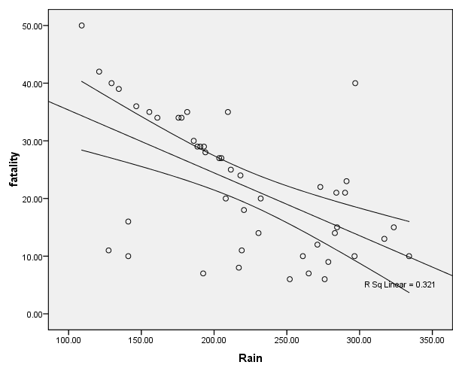

شکل 7-ارتباط بین بارش وتلفات جانوری در پارک ملی و منطقه حفاظت شده سالوک
هرچند ارتباط مستقیم بین میزان خشکسالی و تلفات جانوری پارک ملی سالوک به صورت مستقیم قابل توجه است اماتأثیرات غیر مستقیم آن برزندگی‌جانوری‌این پارک نیز قابل توجه است. تأثیرات غیر مستقیم خشکسالی‌ها برزندگی جانوری به صورت آسیب پذیری از آتش سوزی‌ها)جدول2) فرار از منطقه و برخورد باوسایل نقلیه، زنده‌گیری توسط روستائیان وشکار غیر مجازقابل بررسی می‌باشد. میزان تأثیر پذیری تلفات جانوری(ستون سوم جدول۱) از آتش سوزی به عنوان یکی از تأثیرات غیر مستقیم خشکسالی درپارک ملی و منطقه حفاظت شده سالوک در نرم افزارspssمورد بررسی قرار گرفت نتایج نشان داد ارتباط معناداری بین آتش سوزی به عنوان تاثیر غیر مستقیم خشکسالی و تلفات جانوری پارک ملی و منطقه حفاظت شده سالوک وجود دارد (جدول۳).
جدول3-رابطه بین خشکسالی و آتش سوزی(سمت چپ)و آتش سوزی و تلفات جانوری(سمت راست)

Correlations
 |  | خشکسالی | آتش سوزی
خشکسالی | Pearson Correlation | 1 | .735**
خشکسالی | Sig. (2-tailed) |  | .000
خشکسالی | N | 47 | 47
آتش سوزی | Pearson Correlation | .735** | 1
آتش سوزی | Sig. (2-tailed) | .000
آتش سوزی | N | 47 | 47
**. Correlation is significant at the 0.01 level (2-tailed).

Correlations
 |  | تلفات جانوری | آتش سوزی
تلفات جانوری | Pearson Correlation | 1 | .514**
تلفات جانوری | Sig. (2-tailed) |  | .000
تلفات جانوری | N | 47 | 47
آتش سوزی | Pearson Correlation | .514** | 1
آتش سوزی | Sig. (2-tailed) | .000
آتش سوزی | N | 47 | 47
**. Correlation is significant at the 0.01 level (2-tailed).

همچنین براساس تجربیات محیط بانان این پارک، در سال‌های خشکسالی بیشتر جانوران این پارک برای دسترسی به آب، به سمت شرقی آن یعنی دره رودخانه روئین جابجا می‌شوند، در این جابجایی به‌ناچار از روستاهای مجاور این پارک عبور می‌نمایند بنابراین یا گرفتار شکارچیان می‌شوند و یا با وسایل نقلیه درحال تردد در جاده‌ مجاور این پارک برخورد نموده از بین می‌روند.
از نظر پهنه‌بندی تاثیرگذاری خشکسالی در پارک ملی و منطقه حفاظت شده سالوک؛دشت جنوبی این پارک به دلیل ارتفاع کم،کمبودمنابع‌آب ومجاورت با مناطق مسکونی بیشترین خسارت مستقیم از خشکسالی‌هارامتحمل شده است. برخلاف دشت‌های جنوبی دره‌های منطقه به دلیل غنی بودن منابع آب آسیب کمتری می‌بینند. همچنین ارتفاعات شمالی این پارک‌به دلیل پوشش گیاهی انبوه در سال‌های خشکسالی به دلیل آتش سوزی بیشترین تأثیرات غیرمستقیم را از خشکسالی‌ها متحمل می‌شوند.
2.1.1 . مخاطرات ناشی از نوسانات دما
به دلیل توپوگرافی متنوع و واقع شدن در مسیر ورود پرفشارسیبری به ایران، پارک ملی سالوک نوسانات دمایی زیادی دارد. این نوسانات برای پوشش گیاهی و زندگی جانوری آن خطرات زیادی به وجود می‌آورد. نوسانات دمایی اگر به سمت افزایش دما باشد مخاطراتش متوجه پوشش گیاهی و اگر به سمت پایین‌تر از میانگین باشد پوشش گیاهی و زندگی جانوری را تحت تأثیر قرار می‌دهد. از زمان تأسیس این پارک تاکنون تلفات جانوری ناشی ازافزایش دما ازاین پارک گزارش نشده است. زیرا به دلیل شرایط کوهستانی دشتی بودن این پارک(شکل۳) جانوران آن می‌توانند با جابجایی، خودرا با این نوسان وفق دهند. اما نوسانات مربوط به کاهش دما مخاطرات گسترده‌ای را برای جانوران این پارک ایجاد نموده که سرما زدگی یکی ازآنها است. این پدیده دراثر ورود زود هنگام وخروج دیرهنگام پرفشار سیبری به منطقه به وقوع می پیوندد.این پرفشار که در اوایل دوره سرد دراطراف دریاچه بایکال شکل می‌گیرد به تدریج گسترده ترمیشود. در اوج فعالیت زبانه‌ای از آن به خاورمیانه می‌رسد. به دليل قرار گرفتن این پارک در شمال خاوری ایران، نخستين مسیر ورود اين پر فشار به ایران( عليجاني،42:1376) این پارک تأثیرات زیادی از این پرفشار می‌پذیرد. با ورود این پرفشاربه منطقه مورد مطالعه دمای این پارک به شدت‌کاهش یافته نوع بارش از باران به برف تبدیل می‌گردد و بیشتر ایستگاههای هواشناسی مجاور آن دمای زیر صفر را ثبت می‌نمایند(جدول۴).
جدول4: متوسط دمای حداقل دما در ماه ژانویه
ایستگاه ها | طول | عرض | ارتفاع | متوسط | متوسط حداقل | حداقل مطلق
بجنورد | 57.19 | 37.28 | 1091 | 5.4- | 10.6- | 16.8-
اسفراین | 29 57 | 02 37 | 1221 | 1 | 7.56- | 15.1-
اسدلی | 57.21 | 37.17 | 1490 | 4- | 7.4- | 17.5-
قوچان | 58.30 | 37.4 | 1287 | 6.5- | 18.7- | 22-
همچنین بررسی اولیه نقشه های سطح زمین و ترازهای بالایی در ژانویه 2008 نشان می‌دهد که در طی روزهای 1 تا 31 ژانویه در تراز 500 هکتوپاسکال، تحت تاثیر قسمت جنوب شرقی پرفشار سیبری است(شکل8). که هسته آن 1045 هکتوپاسکال در شمال دریاچه بایکال بسته شده است. بدین ترتیب با ریزش‌هوای سرد ، بیش از 80 درصد ایستگاه های منطقه و مجاور آن کمترین دماها را از روز اول تا 31 ژانویه ثبت نموده‌اند(جدول4). میزان پایداری و شدت این سامانه می‌تواند باعث از بین رفتن گیاهان گرمسیری دردره‌ها و دشت جنوبی این پارک گردد.
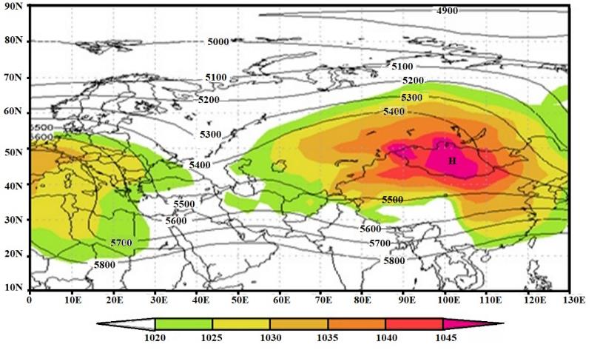
شكل8- نقشه ترکیبی میانگین فشار سطح دریا و ارتفاع ژئوپتانسیل در تراز 500 هکتوپاسکال(روزهای 1 ژانویه تا 31 زانویه 2008)(علیجانی 1371)
همچنین هنگام برخورد این توده هوا با توده مدیترانه‌ای و تشکیل جبهه سرد برف‌های سنگینی در منطقه می‌بارد که سبب سرما زدگی و فرارجانوران به سمت روستا‌های‌مجاور پارک می‌گردد و آمار زنده‌گیری وشکار غیرحرفه‌ای را در این پارک افزایش می‌دهد. ورود زود هنگام اين پرفشار سبب سرمازدگي پائيزي وخروج ديرهنگام آن سبب سرمازدگي بهاري مي‌گردد(مقامي مقيم، 1379: 40) سرمازدگي به‌صورت غيرمسقيم نيز با تأثيربر پوشش‌گياهي، سبب خسارات به جانوران می‌گردد. ارتفاعات سالوک در شمال غربی این پارک در معرض بیشترین آسیب‌های ناشی از سرمازدگی در این پارک می‌باشد.
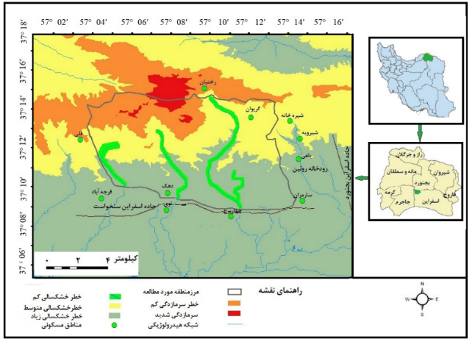
شکل9-پراکندگی مخاطرات آب‌وهوایی در پارک ملی و منطقه حفاظت شده سالوک
یخبندان‌های زمستانی یکی دیگر از مخاطرات دمایی است که تأثیر زیادی در پوشش گیاهی و زندگی جانوری این پارک دارد.این پدیده در150سال پیش توسط ریکناگل به‌عنوان یک مخاطره طبیعی معرفی شد(سازمان‌جهانی آب و هواشناسی،1963). فعالیت این پدیده در منطقه مورد مطالعه ارتباط نزدیکی با فعالیت‌های پرفشارسیبری دارد. یخبندان در منطقه از اواخرآبان شروع شده دردی ماه به حداکثر می‌رسد در اسفند از میزان آن کاسته شده و در فروردین به اتمام می‌رسد.تأثیرات یخبندان به صورت مستقیم سبب فرار و یا کشته شدن حیوانات و به صورت غیر مستقیم سبب تشدید مخاطرات ناشی از ریزش سنگ می‌گردد.
1.2. مخاطرات ژئومورفولوژیکی
بخش زیادی ازمخاطرات ژئومورفولوژیکی، ناشی از ناپایداری دامنه‌ای است که به اشکال مختلفی در سطح زمین مشاهده می‌شود. اسلاي ماركر، این مخاطرات را درسه گروه دینامیک درونی، دینامیک بیرونی ومخاطرات ناشی ازتغییرکاربری اراضی طبقه‌بندی می‌نماید(حافظی مقدس،1388: 133). به دلیل قوانین زیست محیطی، هرگونه فعالیت انسانی در این پارک‌ها ممنوع است بنابراین مخاطرات ناشی از کاربری زمین درمنطقه قابل‌توجه نیست. در بین مخاطرات ژئومورفولوژیکی خطرات توپوگرافیکی اهمیت بیشتری دارد نقش توپوگرافی در ایجاد تنش‌های فیزیولوژیک حرارتی در موجودات زنده پررنگ تر از طول و عرض جغرافیایی است( جلالی، مقامی‌مقیم، فرجی و همکاران، 1398). مخاطرات‌توپوگرافیکی با تأثیر برآب‌وهوا، سقوط‌حیوانات از ارتفاع، حرکات دامنهای و ایجاد تنش‌های فیزولوژیکی هنگام جابجایی حیوانات قابل توجه است. هرچند پارک ملی ومنطقه حفاظت شده سالوک یک محدوده دشتی- کوهستانی محسوب میشود(شکل3 و 4). اما مساحت محدوده کوهستانی آن بیشتر است به همین دلیل در فصول سرد سال بیشتر بارش آن به صورت برف می‌بارد، بارش برفهای سنگین در قسمت کوهستانی شمال این پارک سبب مهاجرت گونه‌های جانوری از نواحی کوهستانی به مناطق گرمسیری جنوب این پارک می‌شود که این امر می‌تواند سبب تخریب پوشش گیاهی این دشت شده فرایند بیابان‌زایی را در آن تسریع‌نماید. این تنش دمایی همچنین می‌تواند سبب پناه آوردن وحوش به روستاهای مجاور پارک شده خطر شکار آنها را افزایش دهد. علاوه بر این قرار گرفتن قله سالوک به عنوان دومین قله مرتفع استان خراسان شمالی در داخل این پارک سبب شده همه ساله کوهنوردان به این قله صعود نمایند که این امر از دو جهت برای پوشش گیاهی و زندگی جانوری این پارک ایجاد خطرمی‌نماید. اولین مورد وقوع آتش سوزی‌های مکرر است که در اثر بی‌احتیاطی کوهنوردان به وقوع می‌پیوندد. بیشتر آتش سوزی‌های به وقوع پیوسته دراین قسمت پارک سالوک در روزهای آخر هفته اتفاق افتاده که بی ارتباط با حضور گردشگران درداخل این پارک نیست. همچنین احساس امنیت حیوانات وحشی نسبت به کوهنوردان می‌تواند سبب کاهش ترس آنها از انسان ها شده آنها را در تیرس شکارچیان قرار دهد. حرکات دامنه‌ای به عنوان بخش دیگری از مخاطرات دینامیک بیرونی این پارک است که در دره‌های آن به وقوع می‌پیوندد. در بین عوامل ناپایداری دامنه‌ها به طور خاص، فرآیندهای ایجاد شده توسط نیروی گرانش، آب های جاری و حرکت موج، که بر دامنه ها و صخره تأثیر می گذارد، و سبب ناپایداری در آن می شوند وسبب ایجاد خطر در پارک ملی پورتوفینو در کشور ایتالیا شده‌اند ( براندولینی،2006).
از میان مخاطرات دامنه‌ای که پارک ملی و منطقه حفاظت شده سالوک را تحت تاثیر قرار می‌دهند می‌توان به ریزش و لغزش اشاره نمود. لغزش، شامل پایین افتادن یکپارچه و نسبتاً سریع مواد در امتداد دامنه‌ها یا سطوح لغزنده است که در اثر عوامل متعدد‎ زمين شناسي، ژئومورفولوژيكي، هيدرولوژيكي، بيولوژيكي و انساني به وقوع می‌‌پیوندد در شروع این پدیده‌ يك محرك خارجي مانندبارندگي شديد، ذوب سريع برف، تغييرات در سطح آب زيرزميني و زلزله نقش محوري دارد. این پدیده در دره‌های پر شیب و آثار باقی مانده فعالیت‌های انسان در قبل از احداث این پارک مانند جاده قدیم اسفراین- بجنورد، مسیر عبور لوله گاز در دره سارمران مشاهده می‌شود. علاوه بر این وقوع سیلاب در قسمت های بالادست دره‌های منطقه سبب ناپایداری و محرک اصلی در وقوع حرکات دامنه‌ای شده است. این فرایند دردره‌های چهار برج و زاری قابل‌مشاهده می‌باشد(شکل۱۲). پدیده ریزش مخاطره دیگری است که درمناطق کوهستانی این پارک به وقوع می‌پیوندد. این فرایند حاصل جداشدن قطعات بزرگ وکوچک سنگ از جدار پرتگاه‌های سنگی است (محمودی،‌ 1386 ،‌36). این فرایند یکی از سریع‌ترین حرکات توده‌ای در نواحی کوهستانی محسوب می‌شود(کاتز، کاپلان، و گوتا،2010:2 ). ریزش غالبا درجایی که رخنمون سنگی، دارای شیب زیادی باشد و تحت تاثیر فرایند تناوبی انجماد و ذوب یا هوازدگی فیزیکی قرارگیرد، رخ می‌دهد. این پدیده دربخش وسیعی از دره‌ها و پرتگاه‌های گسلی این پارک به وقوع می پیوندد و سبب کشته شدن جانوران آن می‌گردد. این پدیده در پارک ملی و منطقه حفاظت شده سالوک به سه صورت واریزه های کلوخی، سنگی و بیولوژیکی(شکل10) به وقوع می پیوندد. واریزه‌های سنگی به ترتیب فراوانی بیشتردر انتهای دره زاری، توی، کوه حسین چاخونی، دره چهاربرج، تخته قرقی و سیاه‌خانه به وقوع می‌پیوندد(شکل۱0). زیرا در این مناطق صخره‌های آهکی سهم بیشتری از ناهمواری‌ها را به خود اختصاص می‌دهند. علاوه بر دره‌ها، پرتگاه‌های ایجاد شده توسط گسل سارمران، شیرویه وپیش‌قلعه نیز از مکان‌های مستعد ریزش سنگی می‌باشند. واریزه‌های کلوخی(خاکی) در بستر دره‌های خشک شکل می‌گیرند. برخلاف سایر حرکات دامنه‌ای در این پدیده رطوبت و شیب نقش چندانی ندارد و اغلب در خاک‌هایی اتفاق می‌افتد که در اثر از دست رفتن رطوبت خشک شده ودر اثرفرسایش رودخانه‌ای ناپایدار شده‌اند. این واریزه ها اغلب در دره های هموار دشت جنوبی این پارک که محل تجمع گروهی حیواناتی نظیرآهو، کفتار، گرگ و شغال ها می باشد به وقوع می‌پیوندد و سبب افزایش تلفات جانوری در این پارک می‌گردد. بخش دیگری از تأثیرات این مخاطره مربوط به فعالیت های جانوری به خصوص خوک ها می باشد که می‌توان آن را واریزه بیولوژیکی نامید.
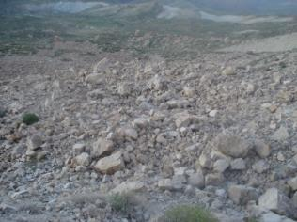
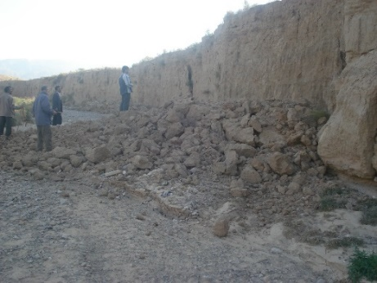
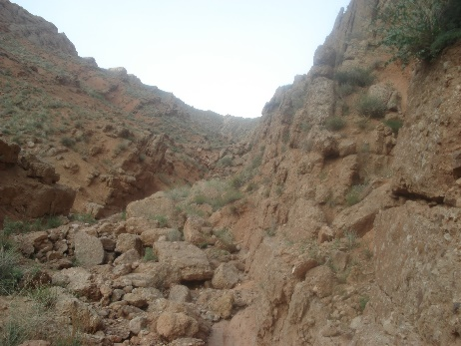
شکل10 - شکل گیری واریزه کلوخی(ابتدای دره زاری ) ( سمت راست) وواریزه های سنگی در انتهای پیش قلعه(تصویر میانی) و واریزه بیولوژیکی در دره حسن چاخونی(تصویر سمت چپ)
به دلیل پوشش گیاهی مناسب، این گونه جانوری به صورت گله‌ای در این پارک زیست می‌نمایند وجهت یافتن ریشه گیاهان زمین را کنده با جابجایی سنگ در شیب‌های تند این مخاطره را ایجاد می‌نمایند(شکل۱0سمت‌چپ). وقوع این پدیده در دره‌های سیاه خانه، باغی و هنگران اتفاق می‌افتد. فرسایش بیولوژیکی مخاطره ژئومورفولوژیکی دیگری است که دشت جنوبی این پارک را تحت تأثیر قرار می‌دهد. در این دشت‌ به دلیل کاهش حیوانات شکاری نظیرگرگ، یوزپلنگ‌وکفتار، تعداد آهوهای آن افزایش یافته است. افزایش این گونه جانوری سبب چرای بیش از حد شده فرسایش بیولوژیکی را دراین قسمت افزایش می دهد و سبب جابجایی و فرسایش خاک به عنوان یکی از مهمترین عناصر زیست محیطی می گردد.
1.3.مخاطرات هیدرولوژیکی
مخاطرات هیدرولوژیکی مربوط به طغیان رودخانه ها است که در فصل بهار به صورت سیلاب‌های مخرب دردره‌ها و مخروط افکنه های این پارک اتفاق می‌افتد. سیل یک چالش مهم در مناطق خشک و نیمه خشک است، جایی که بارندگی غیرمنتظره می‌تواند عواقب فاجعه باری ایجاد کند سیل درپارک ملی کازیرانگا در آسام هندوستان، تنوع زیستی غنی این پارک را تهدید نموده موجب مرگ و یا فرار این گونه‌ها به ویژه کرگدن نمادین تک شاخ از این پارک شده است (پاتان2025). پارک ملی سالوک نیز در منطقه نیمه خشک ایران قرار گرفته و وقوع سیلاب درآن اجنتاب ناپذیر است. از زمان ثبت منطقه مورد مطالعه در ردیف مناطق حفاظت شده ایران(۱۳۵۲) بیش از 30 مورد سیل در آن به وقوع پیوسته‌است(جدول1). این سیلاب‌ها در دره‌های سیاه خانه، چهاربرج، توي و زاري(شکل۱۴) جاری شده است. به دلیل تردد گروهی جانوران در بستر دره‌های این پارک، در بارش‌های ناگهانی این جانوران گرفتار سیل شده جان خود را از دست می‌دهند. علاوه بر دره‌های نامبرده، رودخانه دائمی روئین که درضلع خاوری این پارک جریان دارد و به دلیل آب فراوان نقش مهمی در تأمین آب وحوش این پارک ایفا می‌نماید به دلایلی چون شیب بالا(29 درصد) دارا بودن سازندهای با نفوذ پذیری کم (26 درصد) وقوع بارش‌های رگباری از پتانسیل سیل خیزی بالایی برخوردار است(مردانی،1377: 168 -155). از آنجایی که بخش وسیعی از حوضه آبریز این‌رودخانه ناپایدار است در اغلب بارش‌ها این رودخانه سیلابی شده وبه دلیل u شکل بودن دره آن در برخی قسمت ها، هنگام وقوع سیلاب امکان فرار حیوانات آرامیده در بستر آن کم شده آسیب جدی بر آنها وارد می شود.مانند تلف شدن 530 راس‌دام دامداران مجاور این‌پارک درسیلاب شهریور 1402 (شکل11).
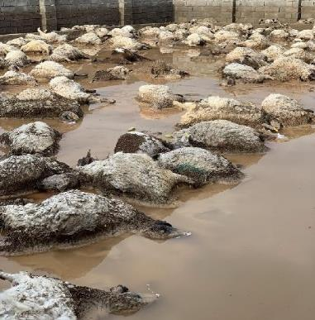
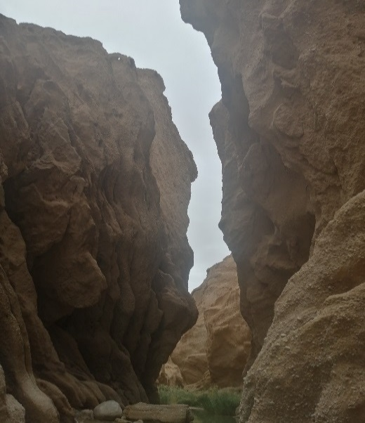

شکل 11- دره U شکل رودخانه روئین در محل تونل دومن نیم( سمت راست) و اجساد دام های به جای مانده از سیلاب شهریور 1402 این رودخانه به نقل از خبرگزاری حکیم مهر شهریور 1402( سمت چپ)
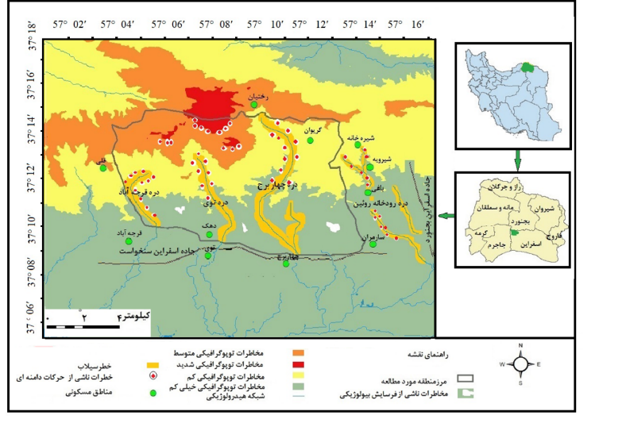
شکل12-نقشه مخاطرات طبیعی پارک ملی و منطقه حفاظت شده سالوک

علاوه بر زندگی جانوری، پوشش گیاهی این پارک نیز در مقابل سیلاب ها آسیب پذیرمی باشند. همچنین سیلاب ها سبب فعال شدن پدیده‌های ثانویه ازجمله حرکات دامنه‌ای در این پارک می‌شوند. در سال‌های خشکسالی نیز به دلیل عبور جاده اسفراین به بجنورد از دره اصلی این رودخانه و جابجایی جانوران برای استفاده از آب این رودخانه، سبب گرفتار شدن آنها در دام شکارچیان یا برخوردآنها با وسایل نقلیه‌ای می‌گردد. موارد فوق سبب شده است تا از نظر مخاطرات هیدرولوژیکی این رودخانه بیشترین خطرات را برای این پارک و منطقه حفاظت شده داشته باشد. همچنین تعداد 10 مخروط افکنه در دشت جنوبی این پارک وجود دارد که در معرض سیلاب های مخرب قرار دارند. این مخروط افکنه هابه دلیل پوشش گیاهی مناسب، محل زیست آهو و کفتارهای این پارک می باشند وقوع سیلاب این مخروط افکنه‌ها آمار تلفات این دوگونه جانوری را افزایش داده است.
نتیجه‌گیری و پیشنهادها
در فرضیات اولیه این پژوهش، فرض براین بود که در بینمخاطرات طبیعی تهدیدکننده پارک ملی و منطقه حفاظت شده سالوک، مخاطرات آب‌وهوایی، ژئومورفولوژیکی وهیدرولوژیکی بیشترین سهم را داشته باشند. پس از مطالعه اسناد واطلاعات موجود در این زمینه، مشخص‌گردید از بین مخاطرات فرض شده، مخاطرات آب‌وهوایی بیشترین خطر را برای این پارک ایجاد می‌نمایند. در بین مخاطرات آب‌وهوایی سهم خشکسالی بیشتر است. خشکسالی به دو صورت مستقیم وغیرمستقیم این پارک و منطقه حفاظت شده راتحت تأثیرقرار می‌دهد. تأثیرات مستقیم این خطربرپوشش گیاهی‌منطقه بیشتراززندگی‌جانوری آن است. دردوره‌های خشکسالی بسیاری از گیاهان منطقه مستقیماً از بین می‌روند. تأثیرات غیر مستقیم خشکسالی بر پوشش گیاهی منطقه به دو صورت آتش سوزی و چرای نا متوازن در مراتع این پارک اتفاق می‌افتد. اغلب خشکسالی‌های این پارک با آتش سوزی همراه است و به دلیل کمبود امکانات اطفا حریق آسیب‌های جدی بر گونه‌های جنگلی آن وارد می‌شود. همچنین در سال‌های خشکسالی به دلیل کمبود علوفه، دامداران به مراتع پارک تعرض نموده با چرای بی رویه‌سبب تخریب آن می‌شوند. هرچند تأثیرات مستقیم خشکسالی بر زندگی جانوری به اندازه پوشش گیاهی نیست اما قابل توجه است و به صورت فرار جانوران از منطقه و کشته شدن آنها تظاهر می‌نماید. درمطالعات کمی نیز ارتباط بین تأثیر مستقیم خشکسالی و تلفات جانوری در نرم افزارspss مورد بررسی قرار گرفت و مشخص‌گردید یک رابطه در حدود0.55- بین بارش به عنوان عامل اصلی و تلفات جانوری وجود دارد بر این اساس هرچه مقدار بارش کمتر از متوسط سالانه یک مکان باشد تلفات جانوری آن بیشتر خواهد بود. همچنین تأثیرات غیر مستقیم این مخاطره بر زندگی جانوری این پارک نیز قابل توجه است و اغلب از طریق آتش سوزی، شکار شدن توسط شکارچیان، زنده‌گیری توسط مردم روستاهای مجاور و برخورد با وسایل نقلیه برآنها اعمال می‌گردد. در سال‌های خشکسالی آتش سوزی‌های در این پارک تلفات جانوری آن را افزایش داده است. همچنین در سال‌های خشکسالی جانوران این پارک به دلیل کمبود آب، به سمت شرقی آن یعنی دره رود خانه روئین جابجا می‌شوند در این جابجایی تعدادی گرفتار شکارچیان می‌شوند تعدادی به دلیل عبور جاده اسفراین - بجنورد از بستر این دره با وسایل نقلیه برخورد می‌نمایند و جان خود را از دست می دهند. همچنین وجود 12 روستای در مجاورت این پارک سبب می‌شوددردوره‌های‌خشکسالی چرندگان این پارک برای خوردن علوفه به باغات، مزارع واُبه‌گاه‌های آنها نزدیک شده درتله شکار آنها گرفتارشوند. تاثیر خشکسالی به عنوان یک عامل آب‌وهوایی بر آتش سوزی در پارک های ملی و مناطق حفاطت شده بامطالعات مشابه انجام شده توسط لسی و همکاران او درسال2024 در پارک ملی یوسیمیتی در منطقه کالیفرنیای آمریکا ولیتل و همکاران او در سال2016همخوانی دارد.
بعد از خشکسالیخطرات ناشی ازنوسانات دما مهمترین تهدید آب‌وهوایی برای این منطقه است. به دلیل واقع شدن این پارک در مسیر ورود پرفشارسیبری به ایران، پدیده سرمازدگی اهمیت زیادی دارد. همچنین برخورد این توده هوا با توده‌های مدیترانه‌ای برف‌های سنگینی می‌بارد که سبب سرمازدگی و پناهنده شدن جانوران به روستاهای مجاور می‌گردد و آمار شکار را افزایش می‌دهد. ورود زود هنگام اين پرفشار سبب سرمازدگي پائيزي و خروج دير هنگام آن سبب سرمازدگي بهاري ميگردد. سرمازدگي به صورت غير مسقيم نيز با تأثير در پوشش گياهي سبب خسارات به زندگی جانوری می‌شود. فعالیت این پدیده در از ماه آبان شروع شده و در دی ماه به حداکثر می‌رسد دراسفند از میزان آن کاسته شده و در فروردین ماه پایان می‌یابد.
پس از مخاطرات آب‌وهوایی، مخاطرات ژئومورفولوژیکی در رده دوم قرارمی‌گیرند. این مخاطرات به صورت حرکات دامنه‌ای در این پارک‌خودنمایی‌می‌نماید. احتمال وقوع این حرکات ازجمله لغزش در دره‌سیاه‌خانه در ضلع شرقی این پارک، ریزش‌خاکی در کانال‌های میانی مخروط افکنه‌های سارمران و چهاربرج در شمال دشت جنوبی این پارک، ریزش‌های سنگی در دره‌های پیش قلعه، صخره ها وپرتگاه‌های ایجاد شده توسط گسل‌های آن در ارتفاعات میانی منطقه و ریزش بیولوژیکی در ارتفاعات شمالی این پارک بیشتر است. حرکات دامنه‌ای به صورت مستقیم به این پارک و منطقه حفاظت شده آسیب وارد می نمایند. همچنین به دلیل کاهش حیوانات شکاری تعداد علف خواران آن افزایش یافته‌ و در اثر چرای فراتر از ظرفیت، شرایط برای فعال فرسایش بیولوژیکی دردشت جنوبی‌این پارک فراهم شده است. نتایج حاصل از مطالعه مخاطرات ژئومورفولوژیکی این پارک با نتایج مطالعات انجام شده در پارک ملی پورتوفینو در کشور ایتالیا توسط براندولینی در سال2006 همخوانی دارد.
ازنظرمخاطرات هیدرولوژیکی به دلیل واقع شدن این پارک در منطقه نیمه خشک وقوع سیلاب در آن اجتناب ناپذیر است. وقوع سیلاب‌های مخرب در دره‌های سیاه‌خانه، چهاربرج، توی، زاری و دره‌های مجاور این پارک همه ساله سبب کشته شدن ده‌ها گونه کمیاب جانوری و نابودی صدها گونه گیاهی‌می‌گردد. نتایح حاصل ازمطالعه تاثیرات مخرب سیلاب های پارک ملی و منطقه حفاظت شده سالوک و نتایح حاصل از مطالعات سیل درپارک ملی کازیرانگا در آسام هندوستان، توسط پاتان در سال 2025 همخوانی دارد.
اما مهمترین نتیجه حاصل از این پژوهش این است که علی‌رغم وجود انواع مخاطرات طبیعی، این پارک همچنان پابر جاست و بسیاری از جانوران درحال انقراض در داخل این پارک به حیات خود ادامه می‌دهند و این دلالت بر این دارد که مخاطرات طبیعی این پارک به صورت طبیعی به عنوان یک عامل تعدیل کننده اکولوژیکی عمل می‌نمایند. و این مخاطرات زمانی می‌تواند بر این پارک اثرات زیانباری داشته باشند که با دخالت‌های منفی انسانی در تعامل باشند اما اگر با اقدامات مثبت انسانی همسو باشند اثرات آنها تأثیر قابل توجهی در این پارک نخواهند داشت. همچنین نتایج کلی حاصل از این پژوهش با نتایج حاصل از پژوهش‌های انجام شده مشابه توسط نیک اندیش در سال1397 در پارک ملی و منطقه حفاظت شده کرخه، دشتی درسال1398 در پارک ملی و منطقه‌حفاظت شده دز و مفیدی ، حسین زاده و ومحمدیاریان در سال 1392 در شمالشرقی ایران همخوانی دارد.
منابع
- احمدي، حسن( 1367). ‍ژئومورفولوژي كاربردي.تهران: انتشارات دانشگاه تهران.
- جعفری، قربان؛ شاهکویی، اسمعیل و قانقرمه، عبدالعظیم. (1397). پیش بینی خشکسالیهای استان خراسان شمالی با مدلHadCM3 و شاخصهای SPI وRDI. مجله آمایش جغرافیایی فضا،8(30)،175-159.
- جلالی، مسعود؛ مقامی‌مقیم، غلامرضا؛ فرجی، عبدالله؛ منصورزاده، علی‌محمد و حسینی‌صدیق، محمود.(۱۳۹۸). بررسی وپهنه‌بندی تنش‌های فیزیولوژیک حرارتی انسان درایران، تحلیل فضایی‌مخاطرات محیطی، ۶ (۴) ،194-177.
- حافظی مقدس، ناصر.(1388). زمین ریخت شناسی کاربردی، شاهرود: انتشارات دانشگاه صنعتی شاهرود.
- حسین‌پور، مریم و فاتحی مرج، احمد . (1397). گزارش فنی: تحلیل مکانی خشکسالی هواشناسی کشور با استفاده از شاخص‌های SPI و PN در نیمه اول سال آبی 93-92 در مقایسه با دوره مشابه سال گذشته، مهندسی و مدیریت آبخیز،10(3)، 505-495.
- خالدی، شهریار.(1377). محیط های طبیعی کره زمین، تهران: ا نتشارات دانشگاه آزاد اسلامی.
- سازمان هواشناسي ايران،اداره کل هوشناسی استان خراسان شمالی.(1354-1400).
- سازمان جغرافيايي نيروهاي مسلح جمهوری اسلامی ایران.(1361)،نقشه توپو گرافي 1:50000 روئین،اسفراین و توی (برگ هاي، IV7464، III7464و II7464
- ظهیری، عبدالرضا؛ شریفان، حسین؛ ابارشی، فرزانه و رحیمیان، مهدی. (1393). ارزیابی پدیده‌های ترسالی و خشکسالی در استان خراسان با استفاده از نمایه‌های .(PNPI, SPI, NITZCHE). نشریه آبیاری و زهکشی ایران.8(4)،856-845.
- عليجاني، بهلول وكاوياني، محمد رضا (1371)، مباني آب وهواشناسي، تهران: انتشارات سمت.
- عليجاني، بهلول. (1376)، آب و هواي ايران،تهران: انتشارات دانشگاه پيام نور.
- محمودی، فرج‌الله.(1386). ژئومورفولوژی دینامیک (رشته جغرافیا)،تهران:انتشارات دانشگاه پیام نور.
- محمودي،ف؛ مقيمي، ا. (1383). روشتحقيق درجغرافياي طبيعي (ژئومورفولوژي) ، نشر قومس
- مردانی، علی اصغر. (1377). بررسی پتانسیل‌های سیل‌خیزی حوضه آبریز رودخانه روئین به منظور بالابردن میزان بهره‌برداری مطلوب از آن، دانشگاه شهید بهشتی - دانشکده علوم زمین ،پایان نامه فوق لیسانس .
- مفیدی، عباس؛ حسین زاده، سیدرضا ومحمدیاریان، محترم(1392). پهنه بندی مخاطرات جوی شمالشرقی ایران، جغرافیا و مخاطرات محیطی،2(6)، 16-1. 16
- مقامي مقيم، غلامرضا.(1379).بررسي محيط زيست منطقه حفاظت شده سالوك اسفراين،پايان نامه كارشناسي ارشد، تهران:دانشگاه شهيد بهشتي .
- نیک اندیش، ارمغان؛ دشتی، سولماز و سبزقبای، غلامرضا (1397) ارزیابی مخاطرات محیط زیستی پارک ملی و منطقه حفاظت شده کرخه بر اساس روش، TOPSIS،نشریه تحلیل فضایی مخاطرات محیطی،5(2)، 72-55.
- نیک اندیش؛ ارمغان، دشتی؛ سولماز و سبزقبائی، غلامرضا. (1398). ارزیابی مخاطرات محیط زیستی در جهت توسعه پایدار در پارک های ملی و مناطق حفاظت شده (مطالعه موردی: پارک ملی و منطقه حفاظت شده دز، جغرافیا و مخاطرات محیطی،8 (1)،63-43.
- وزارت كشور، استانداري خراسان شمالي(1395)، سالنامه آماري 1395 شهرستان اسفراين.
- هاشمی دوین، مهری و آهنگرزاده، زهرا.(1392). پایش خشکسالی هواشناسی استان خراسان شمالی در محیط GIS، نخستین کنفرانس ملی آب و هوا شناسی،کرمان.
References(In persian)
- Ahmadi, H.(1988). Applied Geomorphology. Tehran: Tehran University Press.
- Jafari, G. , Shahkooeei, E. and Ghanghermeh, A. (2019). North Khorasan Province HadCM3 droughts predicted by models and indicators of SPI and RDI. Geographical Planning of Space, 8(30), 159-174.
https://doi. 10.30488/gps.2019.85842.
- Jalali M, Faraji A, Mansourzadeh A M, hosseini seddigh S M. Investigation and zoning of thermal physiological stresses in Iran. Journal of Spatial Analysis Environmental Hazards 2020; 6 (4) :177-194.
http://jsaeh.khu.ac.ir/article-1-2809-fa.html
- Hafezi Moghaddis, N. (2009). Applied Geomorphology, Shahrood: Shahrood University of Technology Publications.
- Hosseinpour, M. and Fatehi Marj, A. (2018). Technical Note: Spatial analysis of meteorological drought during the first half of the water year 1392-1393 compared to the same period of the last water year using SPI and PN indexes in Iran. Watershed Engineering and Management, 10(3), 495-505.
https:// doi: 10.22092/ijwmse.2018.117479
- Khalidi, S. (1998). Natural Environments of the Earth, Tehran: Islamic Azad University Publication.
- Iran Meteorological Organization, General Meteorological Department of North Khorasan Province (1975-1991).
- Geographical Organization of the Armed Forces of the Islamic Republic of Iran. (1982), Topographic Map 1:50,000 of Ruin, Esfahrine and Tuy (Sheets, IV7464, III7464 and II7464)
- Zahiri, A. R. , Sharifan, H. , Abareshi, F. and Rahimian, M. (2014). Assessment the Phenomena of Wet and Drought in Khorasan Province by using (PNPI,SPI,NITZCHE) (Case study: Khorasan Province). Iranian Journal of Irrigation & Drainage, 8(4), 845-856.
https://idj.iaid.ir/article_54846.html?lang=fa
- Alijani, B and Kaviani, M, Reza. (1992), Fundamentals of Meteorology, Tehran: Samt Publications.
- Alijani, B. (1997), Climate of Iran, Tehran: Payam Noor University Press.
- Mahmoudi, F. (2007). Dynamic Geomorphology (Geography), Tehran: Payam Noor University Publications.
- Mahmodi, F. Moghimi, A.,2005 Research in physical geography (geomorphology), compiled, , Ghomes Press, First Edition 2005,Tehran.
- Mardani, Ali Asghar. (1998). Investigating the flood potential of the Ruin River watershed in order to increase its optimal utilization, Shahid Beheshti University - Faculty of Earth Sciences, Master's thesis.
- Mofidi, A. , Hosseinzadeh, S. and Mohammadyarian, M. (2013). Atmospheric Hazards Zonation in the Northeastren of Iran. Journal of Geography and Environmental Hazards, 2(2), -.
doi: 10.22067/geo.v0i0.23110
- Maghami Moghim, G.R. (1990). Environmental Investigation of Saluk Esfarayen Protected Area, Master's Thesis, Tehran: Shahid Beheshti University.
- Nickandish A, Dashti S, Sabzghabaei G. Kharkheh)22018). National Park and Protected Area Environmental Risks Assessment Using TOPSIS Method. Journal of Spatial Analysis Environmental Hazards; 5 (2) :55-72
URL: http://jsaeh.khu.ac.ir/article-1-2627-fa.html
- Nikandish, A. , Dashti, S. and Sabzghabaei, G. R. (2019). The Assessment of Environmental Risks for Sustainable Development in National Parks and Protected Areas (Case Study: Dez National Park and Protected Area). Journal of Geography and Environmental Hazards, 8(1), 43-63. doi: 10.22067/geo.v0i0.69860.
- Ministry of Interior, North Khorasan Governorate (2016), Statistical Yearbook 2016 of Esfarayen County.
- Hashemi Devin, M. and Ahangarzadeh, Z. (2013). Meteorological drought monitoring of North Khorasan province in GIS environment, First National Conference on Climatology, Kerman.
References(In English)
- Buckley, R.c., &Brough,p.(2017).Economic value of park via human mental health:an analytical framework. Frontiers in Ecology and Evolution,5,16.
https://doi.org/10.3389/fevo.2017.00016
- Brandolini, P., Faccini, F., and Piccazzo, M.: Geomorphological hazard and tourist vulnerability along Portofino Park trails (Italy), Nat. Hazards Earth Syst. Sci., 6, 563–571, https://doi.org/10.5194/nhess-6-563-2006, 2006.
- Breuer,Thomas.(2005).Diet choce of large carnivores in northern Cameroon. African Journal of ecology 43.2 :97-106
DOI: 10.1111/j.1365-2028.2005.00551.x
- Katz, I., Kaplan, A., and Gueta, G. (2010). Students’ needs, teachers’ support, and motivation for doing homework: a cross-sectional study. J. Exp. Educ. 78, 246–267.
doi: 10.1080/00220970903292868
- Lacey E. Hankin, Sarah A. Crumrine, Chad T. Anderson(2024) Impacts of mega drought in fire-prone montane forests and implications for forest management, Forest Ecology and Management, Volume 564, 122010, ISSN 0378-1127, https://doi.org/10.1016/j.foreco.2024.122010.
- Littell, J. S., Peterson, D. L., Riley, K. L., Liu, Y., & Luce, C. H. (2016). A review of the relationships between drought and forest fire in the united states. Global Change Biology, 22(7), 2353-2369.
https://doi.org/10.1111/gcb.13275
- Mosaffaei, Z., Jahani, A., Zare Chahouki, M.A., Goshtasb, H., Etemad, V., & Saffariha, M. 2020.
Soil texture and plant degradation predictive model(STPDPM) in national parks using artificial neural network (ANN). Modeling Earth Systems and Environment 6:715–729
DOI: 10.1007/s40808-020-00723-y
- Ngugi,I.R.E.N.E.(2000).Economic impacts of marine protected areas:A case study of the Mombasa Marine park.
https://www.vliz.be//en/imis?module=ref&refid=225137 [2025-03-15]
- Orozco MM, Enriquez GF, Cardinal MV, Piccinali RV, Gürtler RE.(2016) A comparative study of Trypanosoma cruzi infection in sylvatic mammals from a protected and a disturbed area in the Argentine Chaco. Acta Trop. 2016 Mar; 155:34-42
doi: 10.1016/j.actatropica.2015.12.004..
- Pressey, R. L., Visconti, P., & Ferraro, P. J. (2015). Making parks make a difference: poor alignment of policy, planning and management with protected-area impact, and ways forward. Philosophical transactions of the Royal Society of London. Series B, Biological sciences, 370(1681), 20140280.
https://doi.org/10.1098/rstb.2014.0280
- Pathan, S. A., & Tep, G. (2025). Identification of flood-prone areas in Kaziranga National Park, Assam, India. International Journal of River Basin Management, 1–15.
https://doi.org/10.1080/15715124.2025.2477161
- WMO.,(1963).Protection Against frost damage.tecnical Note . No 51,WMO No.133.pp62

1- Ngugi
- Mombasa Marine Park 2
1-Buckley and berau
2- Breuer
3-Farou
4- Pressey et al
5- Visconti
6- Ferraro
7- Orozco et al.
8- Enriquez
9- Cardinal
Lacey -
Littell -
Recknagle-1
Portofino -
1- Katz
2- Kaplan
3- Gueta

